MPEX Science Impurity Transport Challenge 2025:
Impurity transport and target deposition in MPEX-like configurations – a toy model

Motivation
MPEX requires a robust and reliable high fidelity impurity transport code suite – from impurity production, transport along the plasma column, and deposition on a target. In anticipation of tilted-target experiments in Proto-Lite, the MPEX Science team needs to identify an impurity transport model that can reliably be used to interpret impurity deposition measurements and validate these simulations for later use in MPEX. The model should take into account all relevant physics effects (including but not limited to changes in sheath geometry that occur when tilting the target, reflection, and re-erosion).

The Brief
Using your impurity transport simulation package, set up the following “simplified” configuration representing a cylindrical plasma column depositing on a tilted planar target:
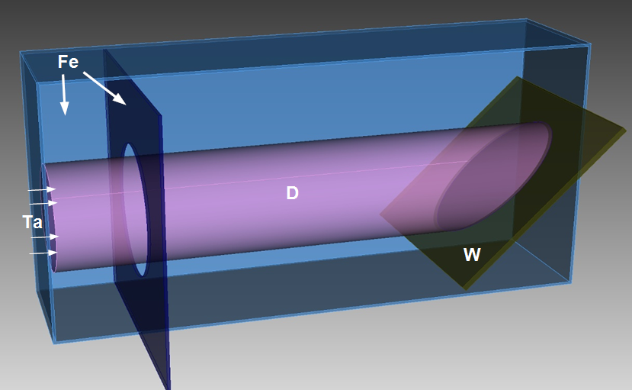
Figure 1: Simplified near-target geometry: cylindrical plasma with tilted planar target
The simulation setup should include:
An iron bounding box, 10 cm x 10 cm x 20 cm.
A tungsten planar target, 8 cm x 8 cm, centered 5 cm upstream of the downstream end of the bounding box.
An iron skimmer/baffle with inner diameter 5 cm, placed 3 cm downstream of the upstream end of the bounding box.
A deuterium plasma column, with nominal diameter 4 cm.
Given an incident tantalum impurity flux, please simulate the impurity deposition pattern (after a specified plasma duration) that you would expect to form on the tungsten target at three different target tilt angles, representing qualitatively different sheath regimes:
- Normal to plasma column (an azimuthally-symmetric Debye sheath regime)
- 45° from plasma column (roughly a non-azimuthally-symmetric Debye sheath regime)
- 85° from plasma column (a non-azimuthally-symmetric Chodura sheath regime)
A series of plots are requested for each case given above:
- Sheath potential along z-axis from sheath entrance to surface
- EADs for both incident ions and sputtered atoms
- Charge state distributions of Ta at the sheath edge
- The spatial distribution of the areal density of tantalum on all surfaces, including the planar target, skimmer, and bounding box. Use a spatial resolution that you think makes sense for each surface. Please show the deposition after both of the following exposure times:
- 0.5 seconds (approximately 1 Proto-Lite discharge)
- 100 seconds (moving towards an MPEX-relevant timescale)

Plasma model
The long-range transport of impurities is not the focus of this challenge, so please utilize the following simplified analytic plasma prescription:
Uniform axial magnetic field, $B_{∥} = 0.5 T$
Deuterium plasma
No parallel variation in plasma parameters between upstream boundary and sheath entrance
Density and temperature take a super-gaussian form with nominal radius of 2 cm:
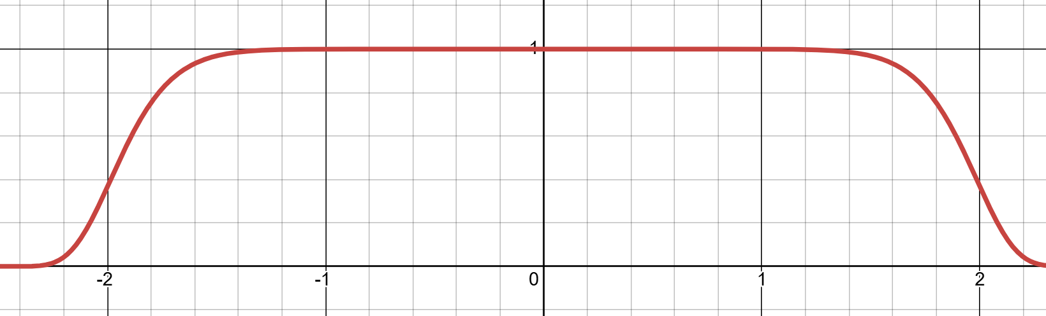
Figure 2: Super-gaussian function exp(-(r/(2 cm))¹²)
  - $n_{e}\left(r\right)=\left(1e19 m^{-3}\right)\exp\left(-{\left(\frac{r}{2 cm}\right)}^{12}\right)$
  - Maxwellian temperature distribution, with
$$T_{e}\left(r\right)=T_{i}\left(r\right)=\left(1 eV\right)+\left(4 eV\right)\exp\left(-{\left(\frac{r}{2 cm}\right)}^{12}\right)$$
  - $v_{∥}=E_{∥}=0$
Tantalum impurities enter from the upstream boundary of the plasma column, with the following characteristics:
  - $Γ_{Z}\left(r\right)=\left(1e20 m^{-2}s^{-1}\right)\exp\left(-{\left(\frac{r}{2 cm}\right)}^{12}\right)$
  - $T_{Z}\left(r\right)=5 eV$
  - $v_{∥,Z}\left(r\right)=1000 m/s$
  - Charge state distribution: 8% Ta²⁺, 62% Ta³⁺, 30% Ta⁴⁺ (approximate CR equilibrium)

Sheath model
For the region between the sheath entrance and surface, please implement whichever sheath model that you think is appropriate to capture the relevant physics for each case.

Surface model
Sputter and reflection yields are not the focus of this challenge, so please utilize the following prescribed representative yields. For sputtering (Y) for (projectile → target) pairs, assume the following fixed yields, regardless of incident angle or energy:
Y (D → W) = Y (Ta → W) = 0
Y (D → Fe) = Y (Ta → Fe) = 0
Y (D → Ta) = 0.001
Y (Ta → Ta) = 0
For particle reflection (R_{N}) and energy reflection (R_{E}) for the relevant (projectile → target) pairs, assume yields that are independent of energy but have the following angular dependence (inspired by the fit functions and parameters in Eckstein IPP report 17/12, 2009), where θ is the incident angle relative to normal in degrees:

R_{N} (Ta → W) = R_{N} (Ta → Ta) = $0.71+0.7 tanh⁡(2.09\frac{θπ}{180}-2.63)$
R_{E} (Ta → W) = R_{E} (Ta → Ta) = $0.93+0.93 tanh⁡(2.7\frac{θπ}{180}-4.12)$
R_{N} (Ta → Fe) = R_{E} (Ta → Fe) = 0
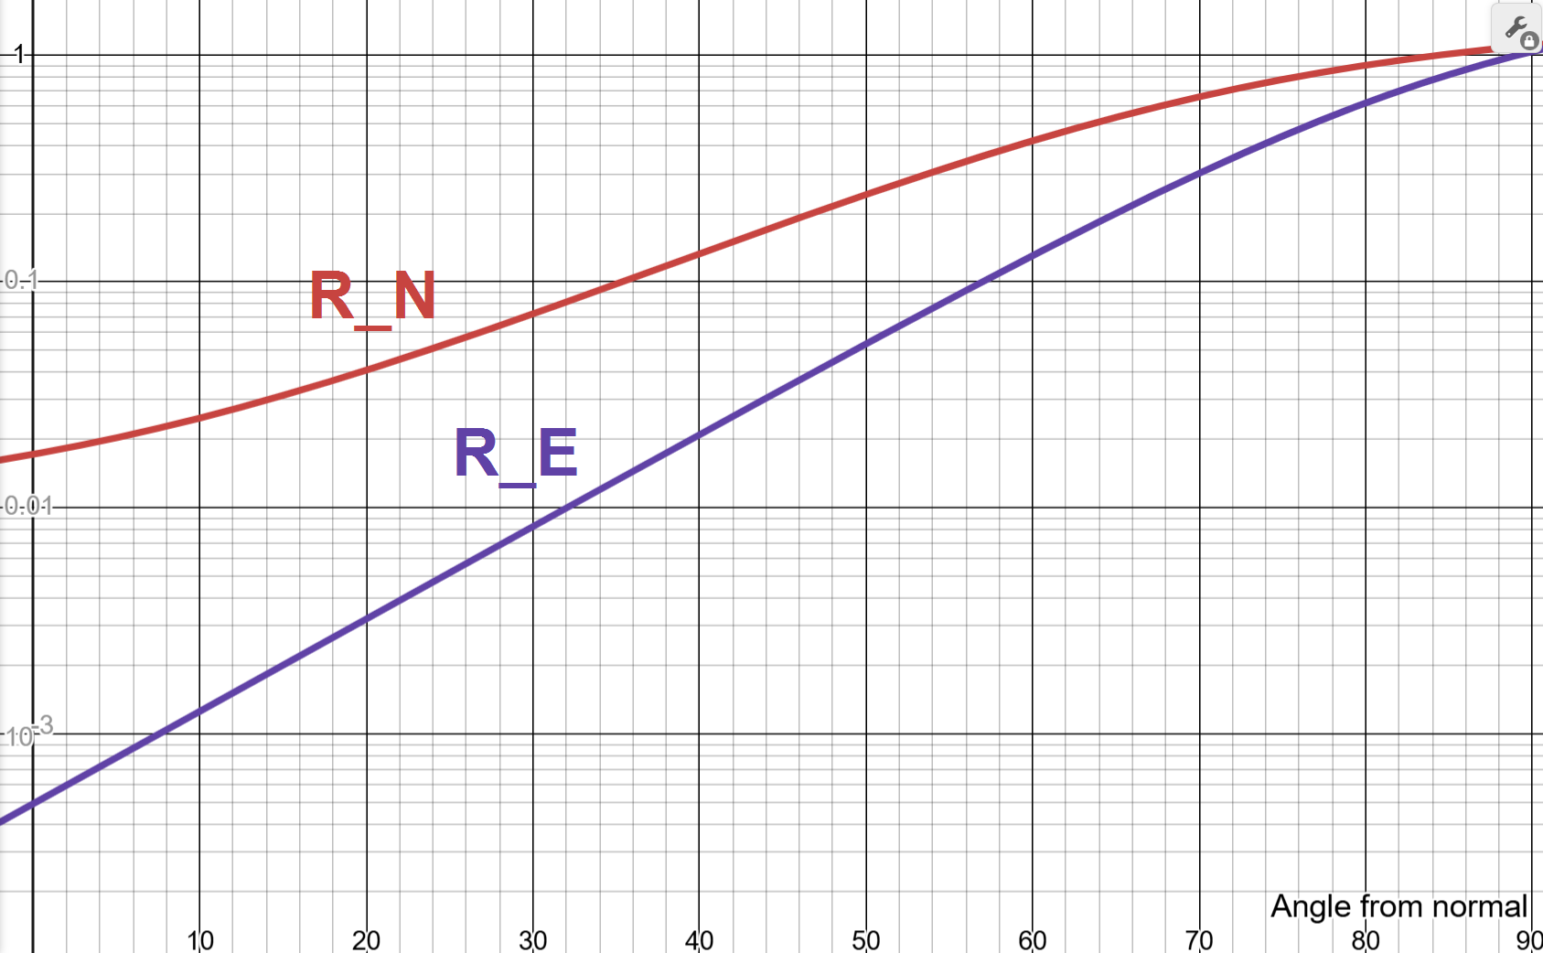
Figure 3: Angular dependence of Ta reflection yields

Other considerations
Participants are welcome to demonstrate and discuss other features of their code that they feel are relevant and noteworthy, so long as these features are in addition to (not instead of) completing the brief.

Timeline and Resources
Initial results will be presented to the MPEX Science team (via a ~15 minute talk) on December 17th, 2025 for feedback. A final report will be asked for ~one month later.
Participants will each be allocated 100 hours (from MPEX Science Modeling) to carry out this challenge. Plus-ups may be supplied on reasonable request.

Challenge Judgement Criteria
How well the presented calculations meet the physics model requirements laid out in the brief. If any given requirement is not met, explain why.
Extent to which the final deposition patterns and trends make sense to PMI experts, given the input assumptions.
Computational performance of the code. Is it fast for this test case? Can it also scale to take advantage of resources if the problem demands it?

